USE CASE

SPECIFICATION

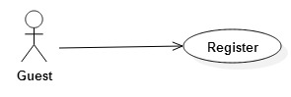

|  |  |  |  |  |
| --- | --- | --- | --- | --- |
| USE CASE – 001 SPECIFICATION | | | | |
| Use case No. | 001 | | Use case version |  |
| Use case Name | Register | | | |
| Author | ThiTD | | | |
| Date | 18/05/2015 | | Priority |  |
| Actor: Guest.  Goal: Guest now has an account to log in the system.  Triggers: Click “Register” link.  Preconditions: Guest has full personal information.  Post-condition: All register information must be valid then it’s saved as an account. | | | | |
| Actors action  Main Success Scenario:  1. Guest click on “Register” link.  3. Guest input all required field.  4. Click “Submit” button.  Alternative Scenario:  4. Click “Cancel” button.  Exceptions:  3. Users input invalid data. | | System response  2. Display “Register” page with many text fields that required for an account.  5. System creates new account for Guest.  6. Put a message that require Guest to log in the system.  5. Redirect to “Home” page.  5. Validate all input data. Send warning messages if invalid. | | |

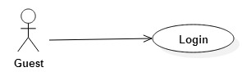

|  |  |  |  |  |
| --- | --- | --- | --- | --- |
| USE CASE – 002 SPECIFICATION | | | | |
| Use case No. | 002 | | Use case version |  |
| Use case Name | Login | | | |
| Author | ThiTD | | | |
| Date | 18/05/2015 | | Priority |  |
| Actor: Guest.  Goal: Guest log in the system successfully.  Triggers: None.  Preconditions: Guest has an account.  Post-condition: Guest becomes Student or Teacher and can use other things in system. | | | | |
| Actors action  Main Success Scenario:  1. Guest input all required field.  2. Click “Login” button.  Exceptions:  1. Users input invalid data. | | System response  3. Accepts the data and let Guest join the system as Student or Teacher  3. Validate all input data. Send warning messages if invalid. | | |

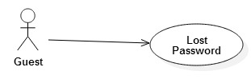

|  |  |  |  |  |
| --- | --- | --- | --- | --- |
| USE CASE – 003 SPECIFICATION | | | | |
| Use case No. | 003 | | Use case version |  |
| Use case Name | Lost password | | | |
| Author | ThiTD | | | |
| Date | 18/05/2015 | | Priority |  |
| Actor: Guest.  Goal: Guest gets password back.  Triggers: Click “Lost Password” link in Login box.  Preconditions: Guest has an account.  Post-condition: Guest can get password back and use it to login the system. | | | | |
| Actors action  Main Success Scenario:  1. Click “Loss password” button.  3. Guest input all required field.  4. Click “Submit” button.  Alternative Scenario:  4. Click “Cancel” button.  Exceptions:  3. Users input invalid data. | | System response  2. 2. Display “Register” page with many text fields that required for an account.  5. System accepts the data and let Guest know the password through his/her email box.  5. Redirect to “Home” page.  5. Validate all input data. Send warning messages if invalid. | | |